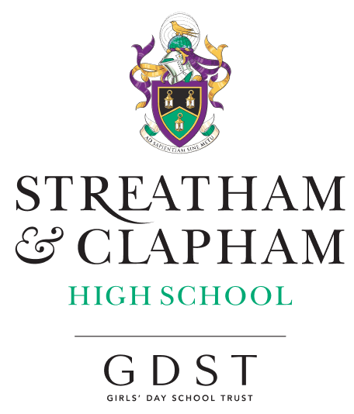

**Leavers’ Destinations**

Date: August 2024

**2024 University Leavers’ Destinations**

|  |  |  |
| --- | --- | --- |
| Manchester Metropolitan University | Criminology | 2024 |
| SOAS University of London | Business, Management, Economics, and Law with Foundation Year | 2024 |
| University of Bath | Business with work placement | 2024 |
| The University of Edinburgh | Scandinavian Studies and Classics | 2024 |
| University of Reading | Food Business and Marketing with Placement Year | 2025 |
| University of Leeds | International Relations | 2024 |
| University of Central Florida | Business Management | 2024 |
| University of Southampton | Geography | 2025 |
| Oxford Brookes University | Sport and Exercise Science | 2025 |
| Amazon with London Metropolitan University | Degree Apprenticeship in Business | 2024 |
| Newcastle University | Classical Studies and English | 2025 |
| Newcastle University | Sociology | 2024 |
| University of Kent | Computer Science (Artificial Intelligence) with a Year in Industry | 2024 |
| University of Exeter | Communications | 2025 |
| University of Leeds | Geography | 2024 |
| University of Liverpool | Medicine | 2024 |
| University of Exeter | Economics with Industrial Experience | 2025 |
| University of Cambridge | Music | 2024 |
| University of Leeds | Graphic and Communication Design | 2024 |
| University of Leeds | Spanish | 2024 |
| University of Warwick | History | 2024 |
| University of Southampton | Language, Culture and Communication | 2025 |
| University of Bath | Psychology | 2024 |
| University of Manchester | Global Development | 2024 |
| St George's, University of London | Medicine (MBBS) | 2024 |
| Oxford Brookes University | Biological Sciences | 2025 |
| London School of Economics and Political Science, University of London | Philosophy, Logic and Scientific Method | 2025 |
| King's College London, University of London | Chemistry | 2024 |
| University of Leeds | International Relations | 2025 |
| University of Leeds | Fine Art with History of Art | 2024 |
| University of Bristol | History and Italian | 2024 |
| University of Leeds | Psychology with Education | 2025 |
| University of Manchester | Computer Science | 2024 |
| University of Leeds | Philosophy, Politics and Economics | 2024 |
| Newcastle University | Sport and Exercise Science | 2024 |
| University of York | Music | 2024 |
| University of Cambridge | Modern and Medieval Languages | 2024 |
| University of Manchester | Psychology | 2024 |
| Newcastle University | Ancient History and Archaeology | 2024 |
| University of Bristol | Gateway to Medicine | 2024 |
| Northumbria University, Newcastle | Design Foundation Year | 2024 |
| University of Leeds | Neuroscience | 2024 |
| University of Westminster | Biomedical Science | 2024 |
| The University of Edinburgh | Economics | 2024 |
| Durham University | Combined Honours in Social Sciences | 2025 |
| University of Bristol | Theatre and Film | 2024 |
| University of Bath | Criminology with professional placement | 2024 |
| University of Birmingham | Chemistry | 2024 |
| University of Nottingham | American Studies and History | 2024 |
|  |  | 2025 |
| University of Nottingham | Politics and International Relations | 2024 |
| Newcastle University | Architecture | 2025 |
| Oxford Brookes University | Criminology and Politics | 2024 |
| Kingston University | Marketing | 2024 |
| University of Manchester | Politics and Sociology | 2024 |
| Newcastle University | History | 2024 |
| Lancaster University | Marketing and Design | 2024 |
| University of Bath | Natural Sciences with professional placement or study abroad | 2024 |